Overview:

* 7% increase in duels win rate
  + 4% increase in defensive duels won
  + **Adam only won 33% of his 12 defensive duels (Very low)**
  + Carter and Jonah had the best defensive duels rate at 73%
  + 6% increase in offensive duels won
  + Highest Offensive Duels rate are Carter (78%), Quinn (68%), McGee (64%)
  + Lowest Offensive Duels rate are Kai (22%), Brian (24%), Jonah (30%)
* Forward Pass Accuracy 69.48% an increase of 1.4% from Utah and 7.1% from Duke
  + The left flank had 9% more passes than the right flank
  + The left flank was 8.4% more accurate than the right flank
  + Higher Accuracy Players: Adam (85.7%), Carter (81.5%), Nolan (88.5%), Max (85.7%), Jonah (77.3%), and Quinn (78.1%)
  + Lower Accuracy Players: Cole (37.5%), Evan (51.7%), and Kai (50%)
* 11 Deep Completed Passes
* Opponents had 7 Deep Completed Passes
* Crossing Accuracy of 47% (Very High | Goal: 39%)
* 12% increase in long pass accuracy
  + Adam (91%), Nolan (67%), Evan (25%), James (29%), Carter (60%), Jonah (71%), Quinn (100%)
* 25% increase in pass accuracy into final third
* 86% Throw in accuracy an Increase of 2%
* UCSD had 17 shots Opponents had 9

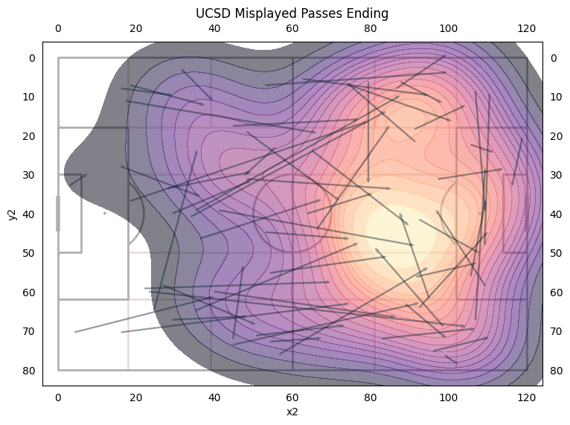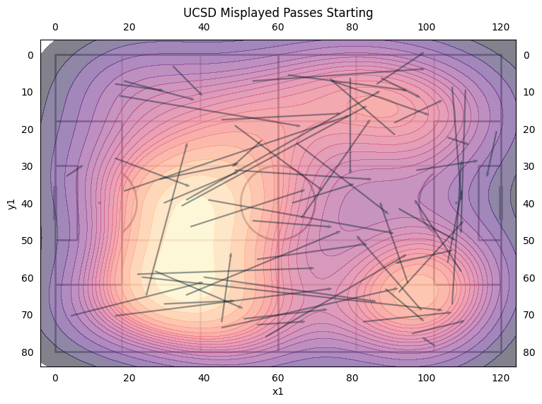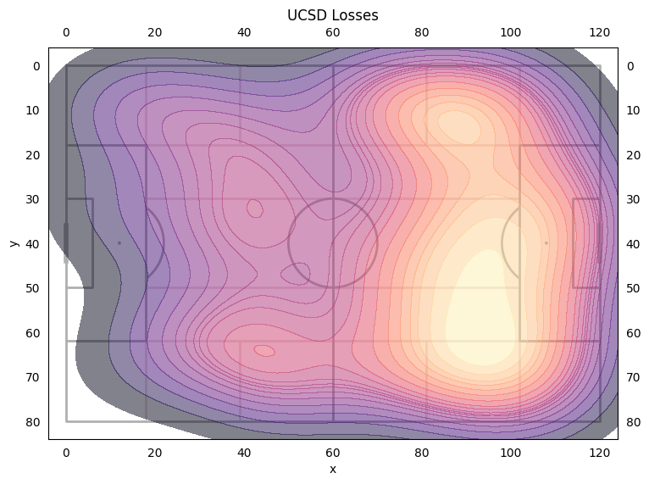

* Most of our losses were in the attacking third
* 54.1% of our losses were duels | 45.9% of our losses were misplayed passes
* Most misplayed passes were into zone 14
* Evan had the most losses at 17, then Jonah at 15, then Cole and Carter at 13, then Quin and Kai at 12
* Won 62.7% of our defensive duels a 4% increase from Utah Valley\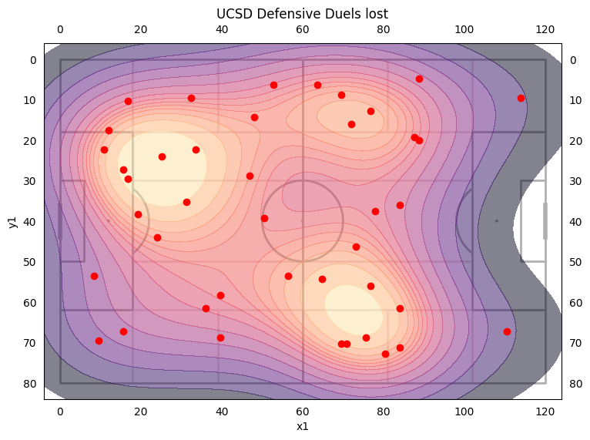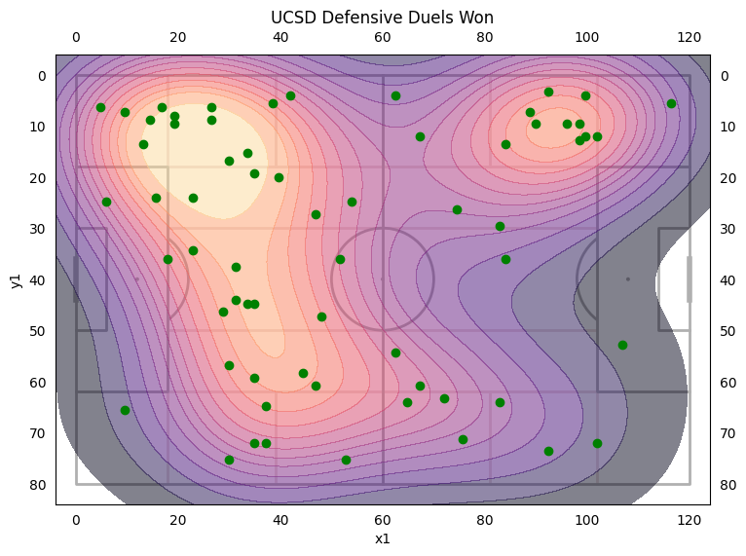
* Won 64% of our defensive duels in our own half
  + Left side won 63% of their duels
  + Right side won 65.2% of their duels
* Adam only won 33% of his duels and lost 8 of his 12
* Cater and Jonah had 15 duels and won 73%
* Quinn and Max had 11 duels and won 64% and 55% respectively
* Won 42.2% of our offensive duels an increase from Utah Valley (36%) and Duke (30%) and last year (39.6%)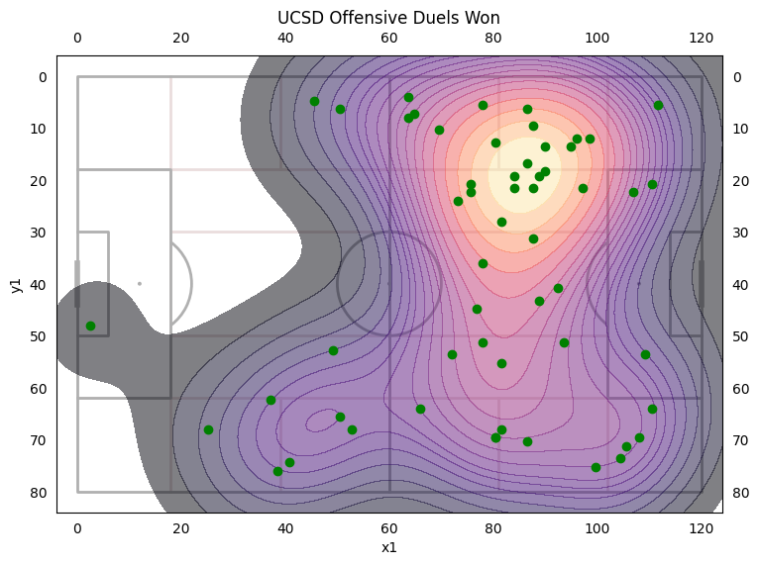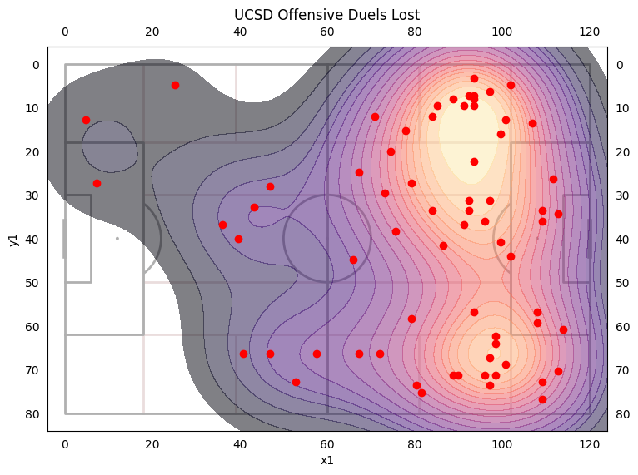
* Left side won 44.1% of their duels
* Right side won 46.4% of their duels
* Quin had 19 duels and won 68%, Kai had 17 duels and won 24%, McGee had 14 duels and won 64%, Max had 14 duels and won 43%, Cole had 11 duels and won 36%, Jonah had 10 duels and won 30%
* Highest winning players: Carter (78%), Quinn (68%), McGee (64%)
* Lowest winning players: Kai (22%), Brian (24%), Jonah (30%)
* UCSD had a forward pass accuracy of 69.48% an increase of 1.4% from Utah and 7.1% from Duke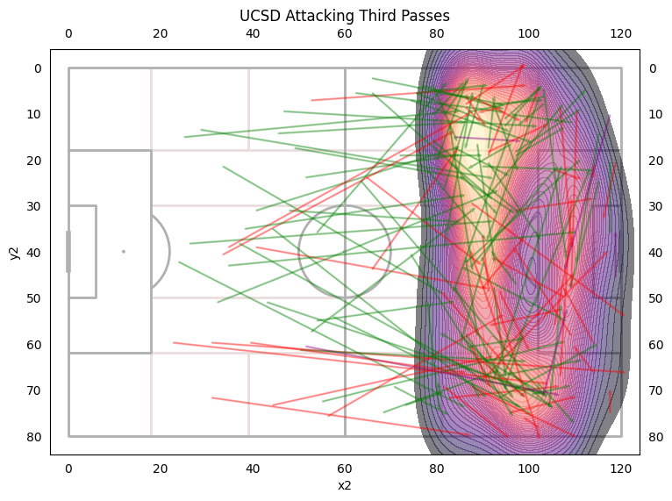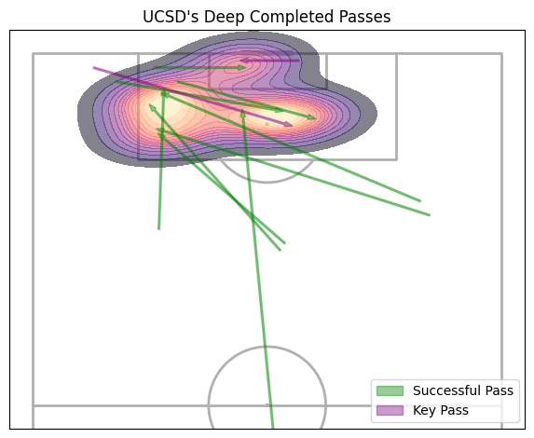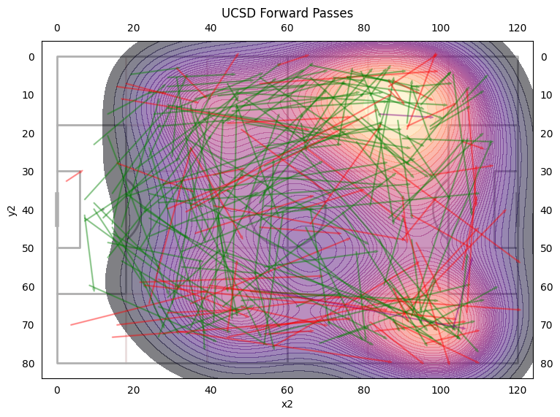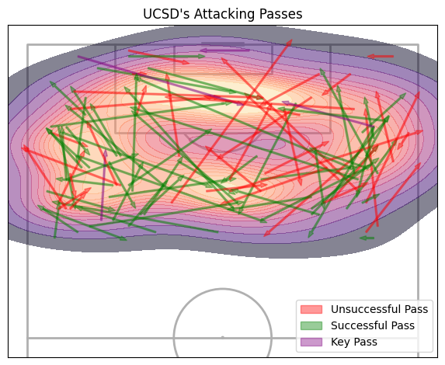
* 43.7% of passes were on the left side. 34.1% of passes were on the right side. 22.4% of passes were switching between sides
* The left side had a pass accuracy of 79.7%. The right side had a pass accuracy of 71.3%. Switches had a pass accuracy of 82.4%
* Majority of deep completed passes were on the left flank with 11 deep completed passes in total an increase from Utah Valley (4)

Forward Passes

Higher Accuracy Players: Adam (85.7%), Carter (81.5%), Nolan (88.5%), Max (85.7%), Jonah (77.3%), and Quinn (78.1%)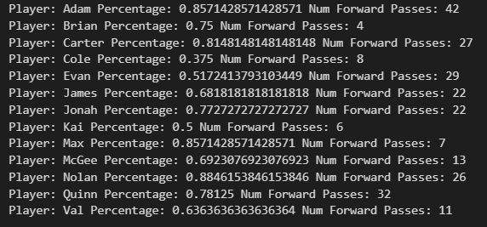

Lower Accuracy Players: Cole (37.5%), Evan (51.7%), and Kai (50%)

Percentage of Passes that are forward

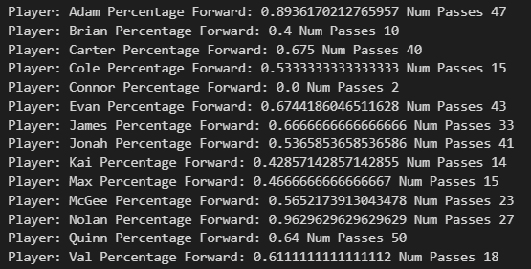

Players that play forward: Adam, Nolan, Evan, Carter

Players that play backward: Brian, Kai, Max

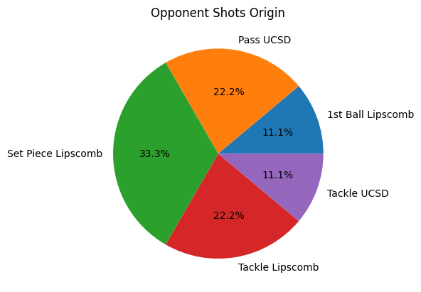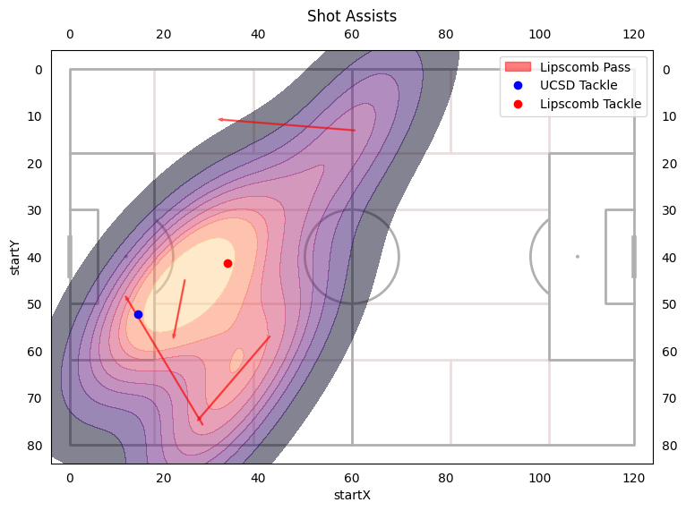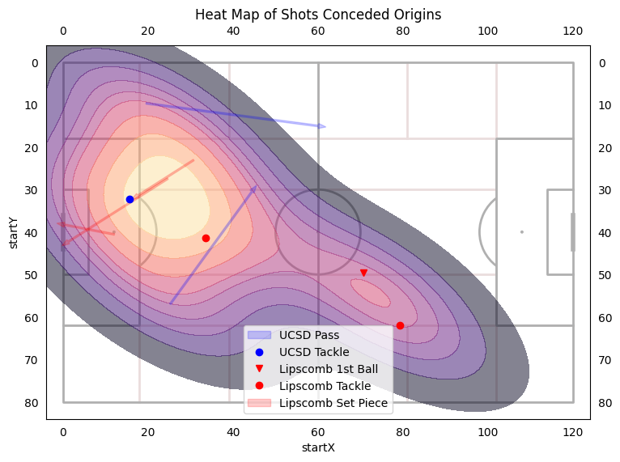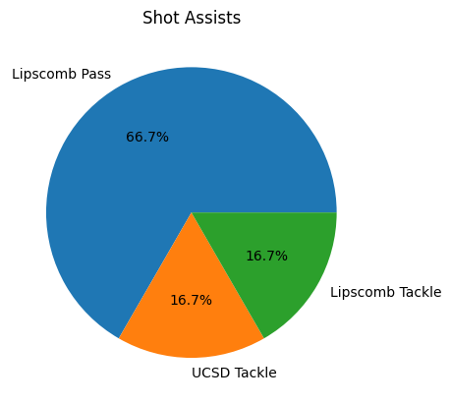

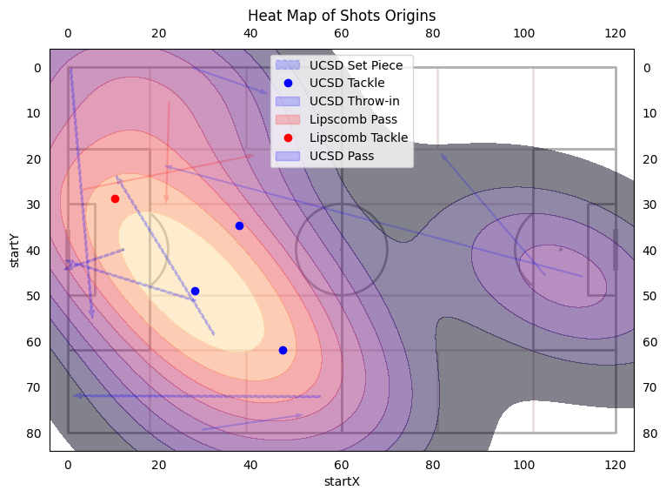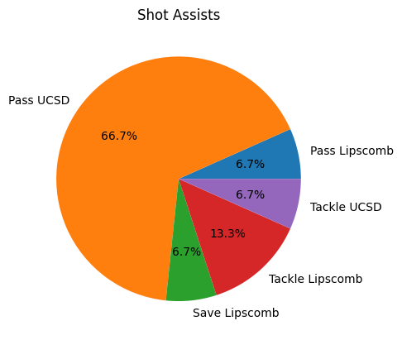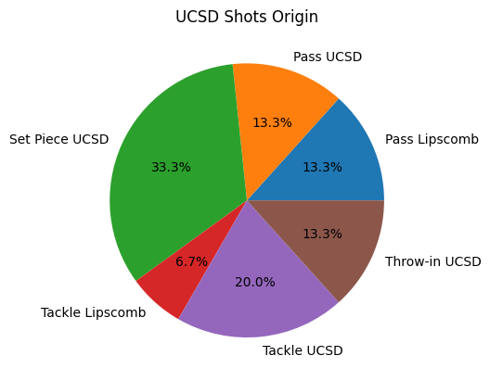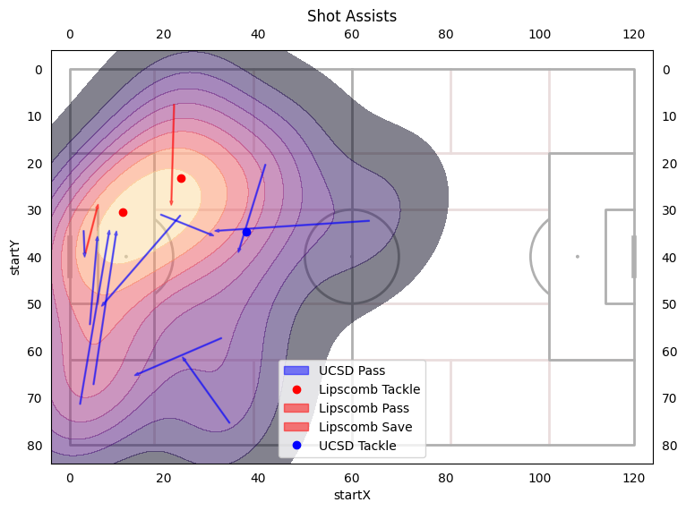

* Majority of our chances came off of set pieces or a turnover from Lipscomb
* Lot of shot assists off of crosses from the left flank